MOVIE IN THE PARK
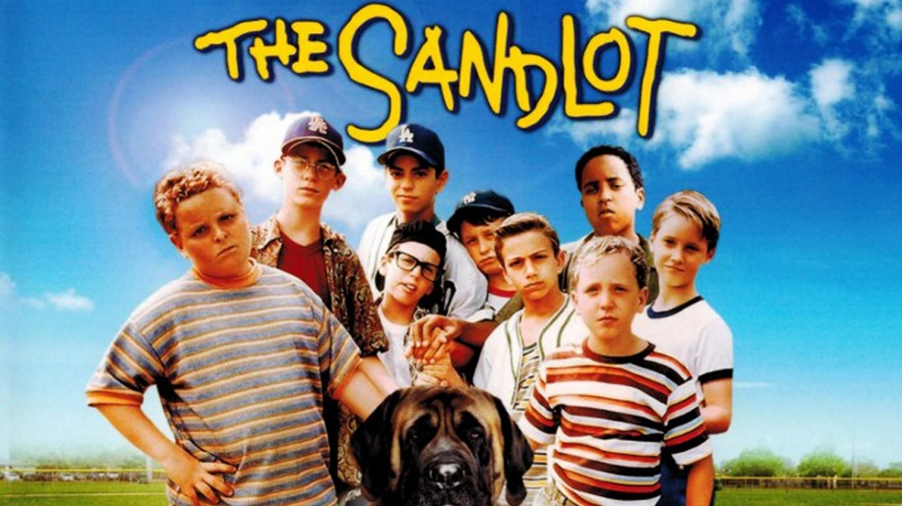
Friday, September 6
Rain Date Sept 13th
FOLLOWING CONCERT BY
NEW BRASS QUINTET
6:30 PM
FREE ADMISSION!
Kensington Park Senior Living
3616 Littledale Road, Kensington, MD

For More Information Contact Betsy Davis at 301-946-7700 or bdavis@kensingtonsl.com

